Quantitative Reasoning Activity

Student Name:

Instructions: Below are the results of two different psychological studies. In the first study, the raw data are presented along with an explanation of the hypotheses explored in the study. In the second study, a graphical representation of the findings is presented for review. Please examine the questions below and provide the information requested for each of the two psychological studies on this document and submit it to the Dropbox no later than Sunday 11:59 PM EST/EDT of Module 5.

Study 1: An industrial/organizational psychologist wants to examine the best predictors of job performance at her company. The organization evaluates employees once a year using the “Employee Performance Evaluation” – a form that evaluates employees on ten important job dimensions and results in scores of 10 through 100 with 100 being indicative of outstanding performance. The other variables available for examination include gender, college grade point average (GPA), and interview score (which ranges from 30 to 80 with a higher score being more positive). The data for the employees of the organization are presented below.

ID | Gender | College GPA | Interview Score | Employee Performance Evaluation
1 | 1 | 3.01 | 50 | 92
2 | 2 | 2.98 | 60 | 78
3 | 1 | 3.49 | 40 | 56
4 | 1 | 3.90 | 30 | 66
5 | 2 | 2.75 | 45 | 78
6 | 2 | 2.89 | 33 | 88
7 | 1 | 2.76 | 56 | 67
8 | 2 | 3.26 | 35 | 72
9 | 1 | 3.65 | 78 | 79
10 | 2 | 3.08 | 87 | 83
11 | 2 | 3.18 | 55 | 86
12 | 2 | 3.33 | 33 | 82
13 | 1 | 2.92 | 32 | 66
14 | 1 | 3.76 | 51 | 99
15 | 1 | 3.21 | 54 | 76
16 | 1 | 2.90 | 49 | 67
17 | 2 | 4.00 | 77 | 89
18 | 2 | 3.82 | 43 | 88
19 | 1 | 3.21 | 56 | 82
20 | 2 | 3.07 | 34 | 78
21 | 1 | 2.94 | 65 | 69
22 | 2 | 3.19 | 62 | 79
23 | 1 | 3.22 | 68 | 84
24 | 1 | 3.41 | 74 | 85
25 | 2 | 3.52 | 34 | 81
26 | 2 | 3.44 | 80 | 90
27 | 1 | 2.78 | 55 | 60
28 | 1 | 3.06 | 59 | 78
29 | 1 | 3.54 | 62 | 88

Using the data in the table above, please answer the following three questions to the best of your ability (NOTE: SPSS is a special program that is available for purchase, but is not required for this course):

- Using VasserStats (http://www.vassarstats.net) or another appropriate software program like Excel or SPSS, compute the mean for the GPA variable and the standard deviation for Employee Performance Evaluation. Fill in the values where indicated below:

Mean for GPA __________

Standard Deviation for Employee Performance Evaluation __________

- Using VasserStats (http://www.vassarstats.net) or another appropriate software program like Excel or SPSS, compute the bivariate correlation (Pearson Product Moment Correlation Coefficient) between the Interview Score variable and the Employee Performance Evaluation variable. Fill in the value where indicated below:

Correlation between Interview Score and Employee Performance
Evaluation __________

- Review the scores of participant 26 in relation to the mean and standard deviation for the Employee Performance Evaluation (Hint: You will need to calculate the mean for this variable but you can use the standard deviation you found in question 1). Based on this information about central tendency and variability, describe in a few sentences how this person performed on the evaluation. Write your responses in the space below:

Study 2: In 2014, The American Psychological Association of Graduate Students (APAGS) conducted a national survey of individuals in doctoral programs to determine the average amount of debt incurred during the process of obtaining either a PhD or PsyD in psychology. The results of their study are presented in the chart below:

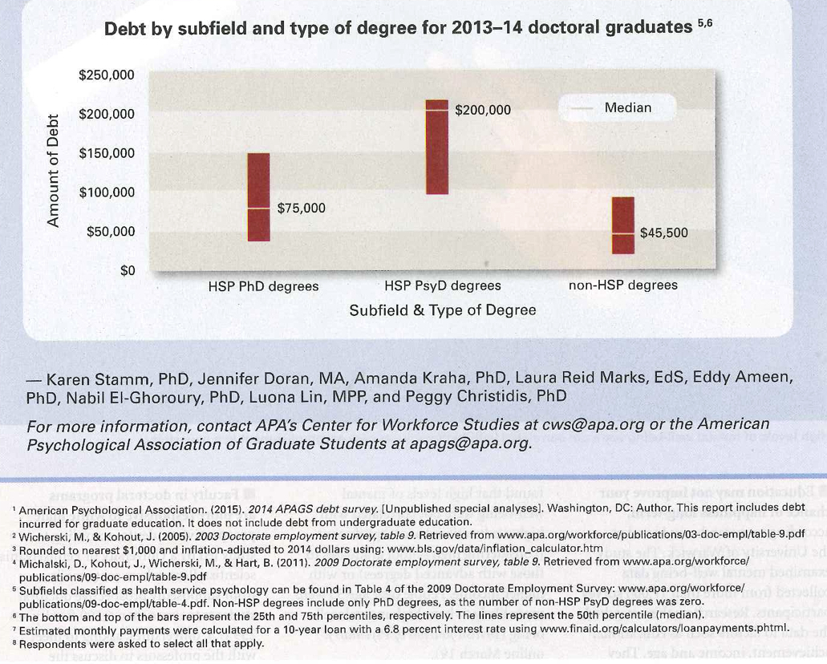

Using the information presented above, please answer the following two questions:

- Which group (Health Service Provision PhD Degrees, Health Service Provision PsyD Degrees or Non-Health Service Provision Degrees) incurred the most debt? Provide your answer in the space below:

- In a short sentence or two, summarize the findings presented in the chart above:

